**Source is fictional**

Shore Leave

Online

Travel Ideas News Hotels Dining Cruises SUBSCRIBE

A Day at the Shore

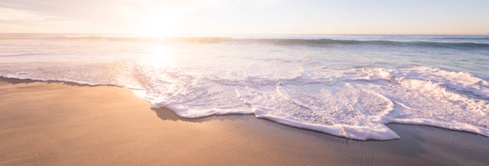

Sandrine Boudreaux | May 31, 2015

A day at the shore has long been a staple of summer fun. Every year thousands flock to our nation’s shores to spend time together, and get fresh air and exercise while enjoying some of the most breathtaking vistas in nature. A day at the shore can be filled with any number of activities capable of creating lifelong memories, but preparation is key to having a good time. So before you pack up the family and hit the beach, here’s what you need to know for a day at the shore.



Shore Leave Online

www.shoreleaveonline.com/dayattheshore